CNH Simulated Orders: The CNH Simulated Orders tab displays all CNH parts orders that have been sent to CNH for verification, but not submitted for processing. Once an order is submitted to CNH, it will no longer appear in this screen.

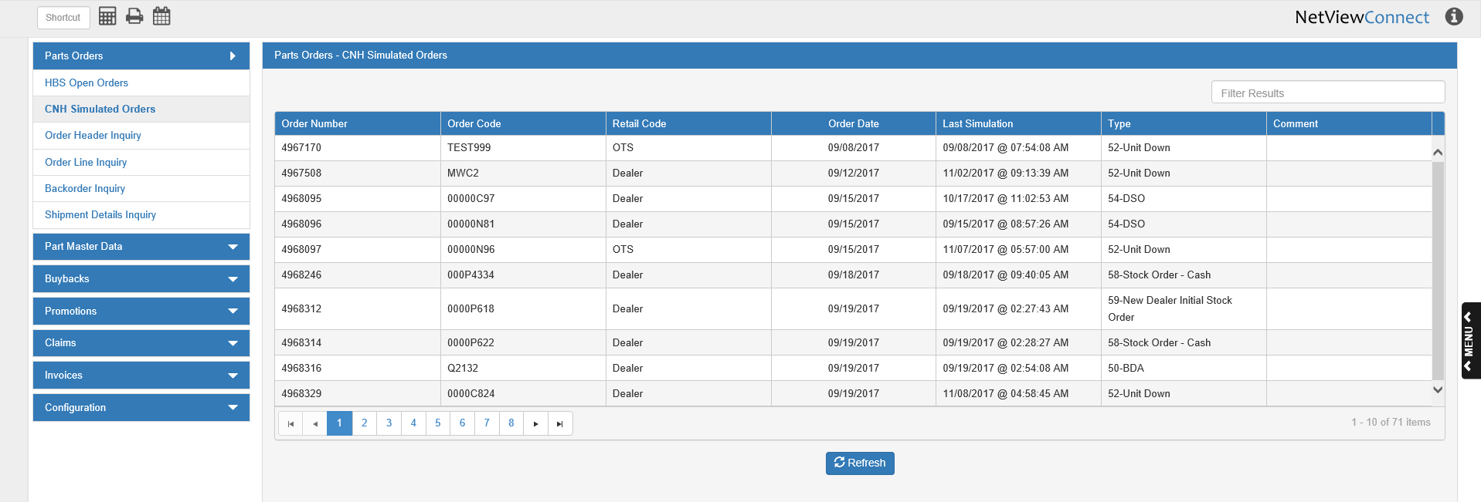

You can sort the orders by clicking on the column headers (once for ascending/alphabetic order, twice for descending/reverse-alpha order). You can also filter the list by entering characters into the Filter Results field; the list will then only show orders that contain the characters you typed in.

Column Definitions:

Order Number: This column shows the CNH-assigned order number.

Order Code: This column shows the dealer-assigned order number.

Retail Code: This column shows the order’s retail code, which indicates whether it is being shipped to:

- The dealer’s default address (Dealer)
- A one-time shipping address (OTS)

Order Date: This column shows the order creation date.

Last Simulation: This column shows the date and time, down to the second, when the order was last sent to CNH for verification. NOTE: An order can be sent any number of times before being submitted, and we recommend you re-send it if your order returned any warnings or errors that required changes.

Type: This column shows the CNH order type code.

Comment: This column shows any comments that have been made on the order.

Refresh: Click this button below the grid to update the order list at any point while using the screen. It will change the list to reflect any newly-simulated orders, changes to orders in another screen, or any submissions made since the screen was accessed.

Viewing Order Details: To view the details of any simulated order, click on the order’s entry in the grid. The following window will open to let you examine the order’s details and perform further actions:

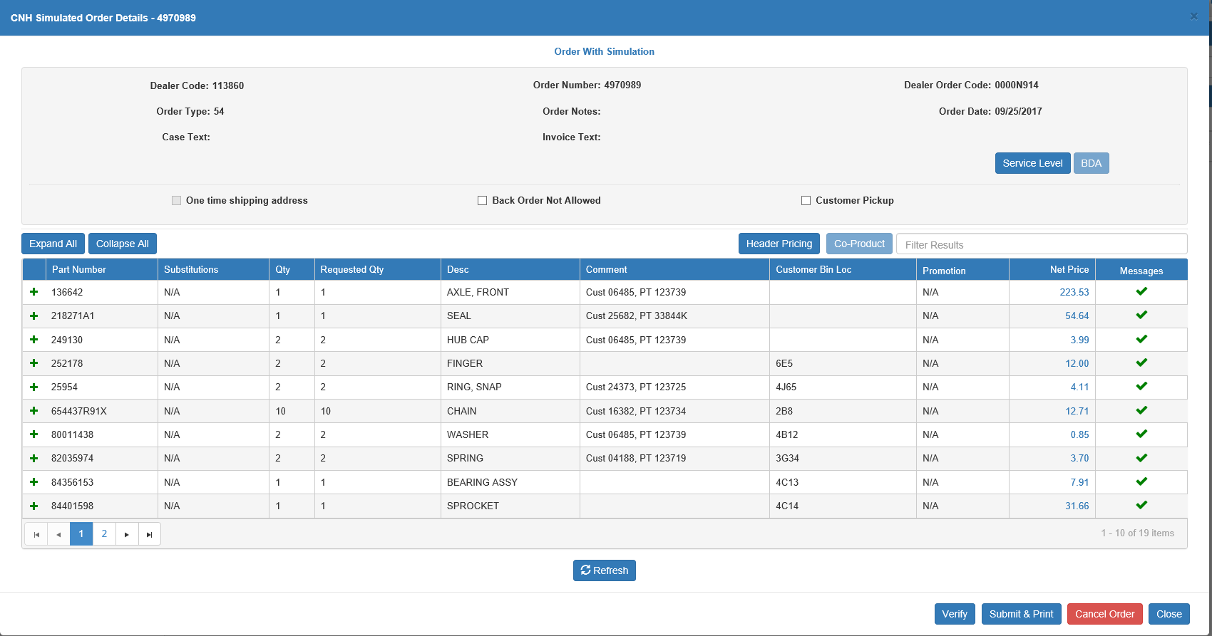

Dealer Code: This field shows the dealer’s CNH code as recorded on the order.

Order Number: This field shows the CNH-assigned order number.

Dealer Order Code: This field shows the dealer-assigned order number.

Order Type: This field shows the order type code.

Order Notes: This field shows any notes made on the order.

Order Date: This field shows the order creation date.

Case Text: This field shows any text that accompanied the order case, if it exists.

Invoice Text: This field shows any text that appeared on the order invoice, if it exists.

Service Level: Click this button to view and manage the order’s service levels by warehouse.

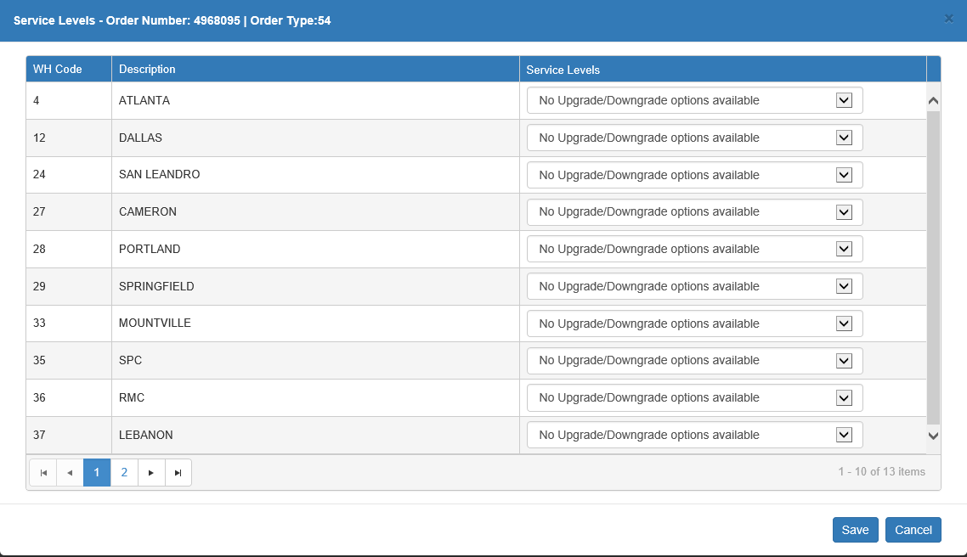

WH Code: This column holds the CNH warehouse code.

Description: This column holds the warehouse description, typically the name of the city where it is located.

Service Levels: Use the drop-down menus in this column to set the desired service levels for the warehouse, provided there are options available. NOTE: You will not be able to use this feature if you have not loaded the service levels from CNH (see Service Level List for more information).

Click Save to save the levels and return to the order details.

BDA: If the order type is 50-BDA, then this button will be active.

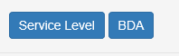

Click it to view and edit the BDA details for the order.

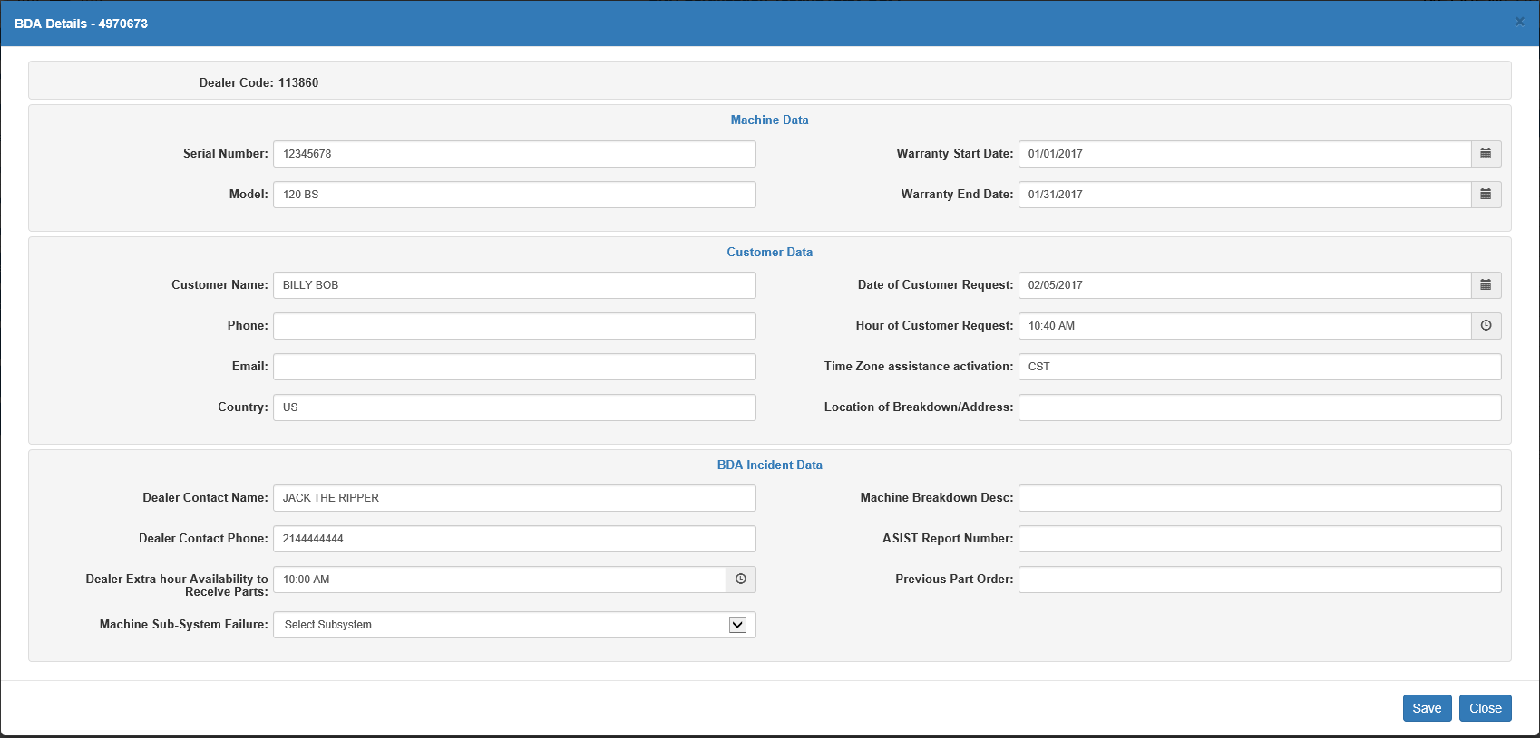

Dealer Code: This field shows the dealer’s CNH code as used on this order.

Machine Data Fields:

- Serial Number: This field holds the serial number for the unit tied to the order. This is a required field.
- Model: This field holds the unit’s model number. This is a required field.
- Warranty Start Date: This field holds the unity’s warranty start date. You can change the date by either typing a new date in or selecting it from the calendar. This is a required field.
- Warranty End Date: This field holds the unity’s warranty end date. You can change the date by either typing a new date in or selecting it from the calendar. This is a required field.

Customer Data Fields:

- Customer Name: This field holds the order’s customer name. This is a required field.
- Phone: This field holds the customer’s phone number.
- Email: This field holds the customer’s email address.
- Country: This field holds the customer’s country of location/residence.
- Date of Customer Request: This field holds the date of the customer’s BDA request. You can change the date by either typing a new date in or selecting it from the calendar. This is a required field.
- Hour of Customer Request: This field holds the hour of the customer’s BDA request. You can change the time by either typing a new time in or selecting the time using the time picking feature. This is a required field.
- Time Zone assistance activation: This field holds the time zone in which the breakdown occurred.
- Location of Breakdown/Address: This field holds the location or address where the breakdown occurred.

BDA Incident Data Fields:

- Dealer Contact Name: This field holds the dealer contact’s name for this order.
- Dealer Contact Phone: This field holds the dealer contact’s phone number.
- Dealer Extra hour Availability to Receive Parts: This field indicates a time outside of the dealer’s regular hours in which they would be available to receive a part delivery.
- Machine Sub-System Failure: This field indicates the CNH BDA subsystem code that best fits the breakdown.
- Machine Breakdown Desc: This field holds a description of the breakdown.
- ASIST Report Number: This field holds the order’s ASIST report number.
- Previous Part Order: This field holds the previous order number for the requested part(s).

One time shipping address: This field indicates whether or not this order will go to a one-time shipping (OTS) address or the dealer’s default address (set up elsewhere in the system).

- If the box is checked, then the fields detailed below will appear above the Order Details grid.
- If it is not checked, the fields will be hidden.
- Regardless of whether or not the box is checked, it will be inactive in this screen; you will not be able to change whether the address is a one-time ship or the dealer’s default at this point.

Name: This field holds the name of the receiving party at the OTS address. This can be a company or an individual.

Attention: This field indicates any particular individual who should receive the order, in the case that the address is for a large group or business.

Address 1: This field holds the primary street address line.

Address 2: This field can hold a second address line, if required.

City: This field holds the city of the address.

State: This field holds the state or province abbreviation for the address.

Zip/Postal Code: This field holds the zip or postal code for the address.

Country: This field holds the country of the address.

Suggested Address for One-Time Ship: When using the One time ship address feature, the system will also verify that you have entered the address correctly, i.e. included the street abbreviation, not left numbers off the zip/postal code, etc. If any part of the address has been entered incorrectly, the system will trigger an error during verification and offer a suggested address alongside the entered one for you to choose between.

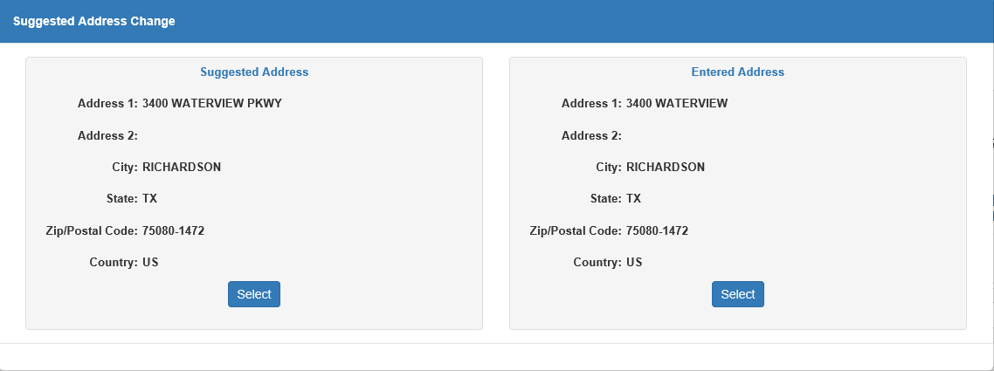

Back Order Not Allowed:

- Check this box to prevent CNH from placing any part of your order on back-order.
- Leave it unchecked to indicate that CNH can make a back-order for the parts on the order if necessary.

Customer Pickup:

- Check this box to indicate that you, as the dealer, will pick up your order from the CNH depot, rather than having it delivered to an address.
- Leave it unchecked to have CNH ship it directly to your address of choice.

Header Pricing: Click this button to view the order’s header pricing details.

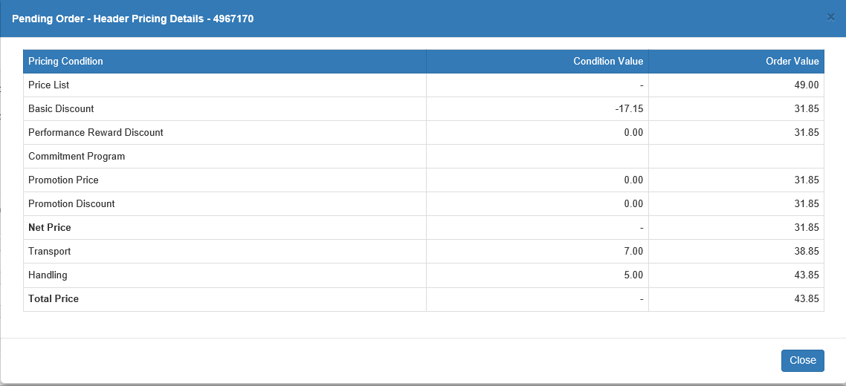

Pricing Condition: This column lists the pricing conditions which affect the order (list price, discounts, net price, etc.).

Condition Value: This column shows the condition values that can be applied to either decrease or increase the price of the order, like discounts or shipping/handling fees.

Order Value: This column shows a running total of the order cost based on the condition values being applied to it. The Total Price entry at the bottom of the grid shows the final price of the order after all conditions are included.

Co-Product: The Co-Product button will only activate if the order is eligible for a particular co-product promotion.

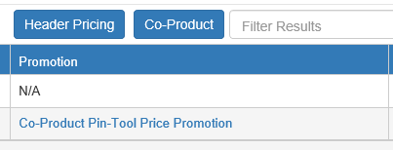

Click the button to view the specific co-product details.

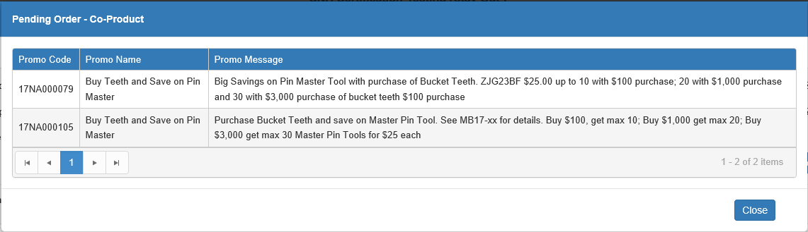

Promo Code: This column shows the promo code.

Promo Name: This column shows the promo’s name.

Promo Message: This column shows the actual promotion details.

Order Details Grid: The grid shows all lines on the order, which can be expanded or collapsed to show more details by clicking on the or 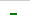 icons in the far-left column of the grid (see image below for an example of an expanded line).

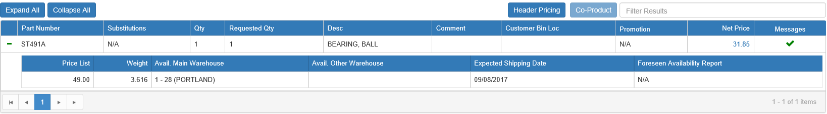

Expand All: Click this button to expand all detail lines on the order.

Collapse All: Click this button to collapse all detail lines on the order.

Filter Results: You can use this field to filter the detail lines by entering specific information. This works best with orders that have multiple pages of detail lines and you only want to see specific ones.

Part Number: This column shows the part number for the order line.

Substitutions: If the part has any available substitutions, this column will show “View Substitution” (see below).

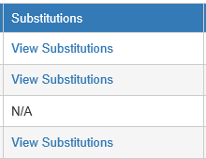

Click the hyperlinked words to view the substitution part’s information.

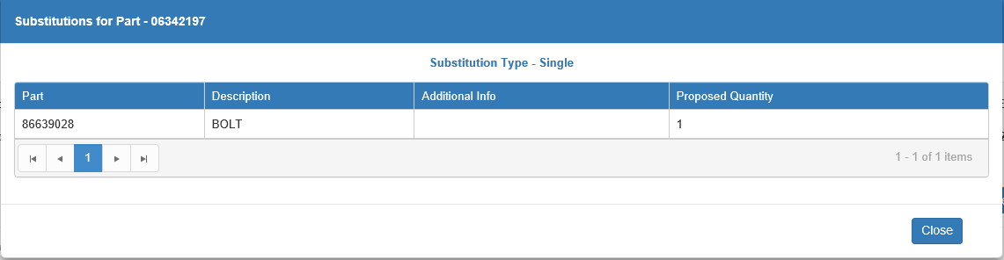

- Part: This column shows the substitute part number.
- Description: This column shows the substitute part’s description.
- Additional Info: This column holds any additional information about the part.
- Proposed Quantity: This column shows the proposed substitution quantity.

Qty: This column shows the quantity of the part recorded for the order line.

Requested Qty: This column shows the quantity of the part originally requested on the order line by the dealer. If this number differs in any way from the value in the Qty column, it may be that a warning or error message applies to your line (for more information, see the section on “Messages” later on in this chapter).

Desc: This column shows the part’s description.

Comment: This column shows any comments made on the order line. If the picking ticket number and customer number are set to print on the order slip in place of the bin location, then the bin location will appear here while the picking ticket number and customer number show in the Customer Bin Loc column.

Customer Bin Loc: This column shows the part’s bin location at your dealership. If the picking ticket number and customer number are set to print on the order slip in place of the bin location, then the picking ticket and customer numbers will show here. In that case, the bin location will show in the Comment column.

Promotion: If the order line is eligible for a promotion, this column will have an entry in it, as shown below:

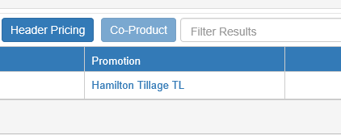

Click on the promotion name to view the promo details.

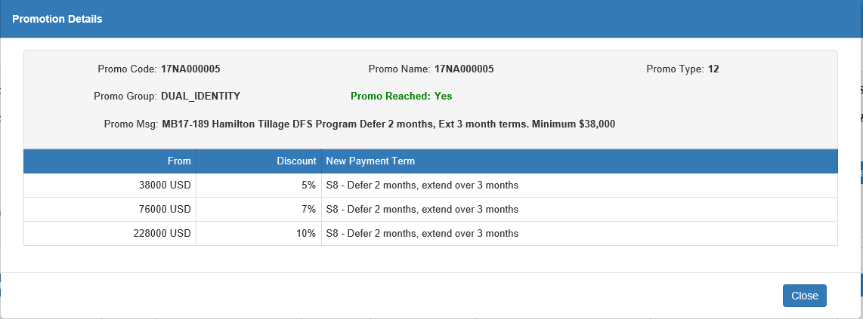

- Promo Code: This field shows the promo code.
- Promo Name: This field shows the promo name.
- Promo Type: This field shows the promo type.
- Promo Group: This field shows the promotion group the promo is classified in.
- Promo Reached: This field indicates whether or not the promotion has been reached.
- Promo Message: This field shows the promotional message, or the actual details of the promo.
- Grid Columns:
  - From: This column shows the minimum purchase amount required for the order line to be eligible for a tier of the promotion.
  - Discount: This column shows the percentage discount that would be applied to the order if it met the minimum purchase amount.
  - New Payment Term: This column shows the new payment term established by that tier of the promo.

Net Price: This column shows the net price of one unit of the part. Click on the price to view the line’s pricing details.

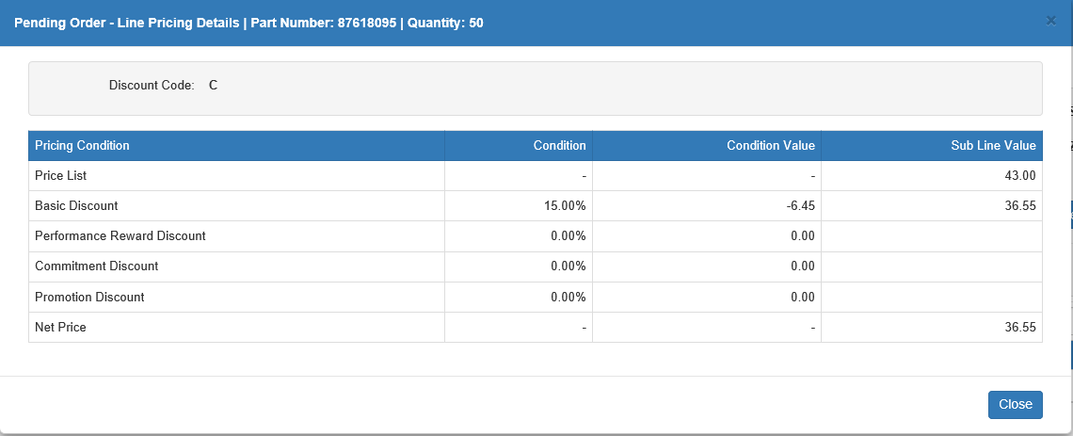

- Discount Code: This field shows the line’s discount code.
- Grid Columns:
- Pricing Condition: This column lists the pricing conditions which affect the line (list price, discounts, net price, etc.).
- Condition: This column shows the percentage represented by the condition which can be used either discount or increase the part’s price.
- Condition Value: This column shows the actual dollar value of the condition, which is determined by applying the condition percentage to the part’s list price.
- Sub line Value: This column shows a running total of the subline cost based on the condition values being applied to it. The net price is the final calculated unit price for the line.

Messages: This column indicates the type of verification message that CNH returned with the order line after verifying it. If a appears in the column, then there are no issues with the line, and subsequently no messages. However, if a or a appears, then there is either a warning or error message respectively on the line. In those cases, click on the icon to view the message from CNH, which will let you know what the issue is.

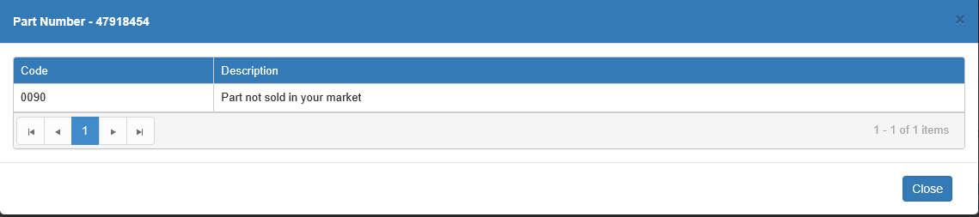

- Code: This column shows the warning or error code.
- Description: This column shows the actual message explaining why the line received a warning or error.

Once you resolve the issue and re-verify the order, the icon should switch to a . Once this icon appears on all the order detail lines, the order is ready for submission to CNH.

Header Messages: It is also possible that, if a warning or error message applies to the entire order, a or a will appear in the upper right-hand corner of the Order Details screen. Click on it to view the header message.

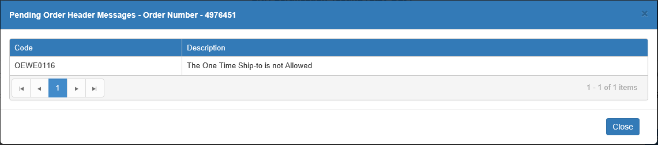

Expanded Grid Columns:



- Price List: This column on the expanded line shows the list price for one unit of the line’s part.
- Weight: This column on the expanded line shows the part’s unit weight.
- Avail. Main Warehouse: This column on the expanded line shows the part’s availability at the dealer’s preferred warehouse. NOTE: To see warehouse availability, the Warehouse list must be loaded from CNH (see Warehouses for more information).
- Avail. Other Warehouse: This column on the expanded line shows the part’s availability at all other CNH warehouses. NOTE: To see warehouse availability, the Warehouse list must be loaded from CNH (see Warehouses for more information).
- Expected Shipping Date: This column on the expanded line shows the part’s expected shipping date.
- Foreseen Availability Report: This column represents a feature that is not fully implemented yet. It will currently show either “BOAT” or “N/A.”

Refresh: Click this button to refresh the order details. The system will update the order with any changes that have been made to the lines since the details were opened.

Verify: Click this button to re-verify the order, particularly if you have made any changes in order to correct errors or warnings. Remember that all lines on the order must be verified without errors before you can submit it to CNH.

Submit & Print: When the order is ready, click this button to submit it to CNH for order processing. The order will disappear from the CNH Simulated Order tab and be shown as a Submitted order in the HBS Open Orders tab. You can also now look it up in the Order Header and Order Line inquiries in order to view information about its processing status. You will also be offered the chance to print your order details using the following window:

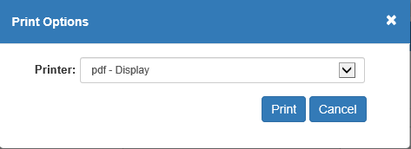

Set your desired printer and click Print to receive the printout. Click Cancel if you are not interested in printing the order details.

Sample Order Printout

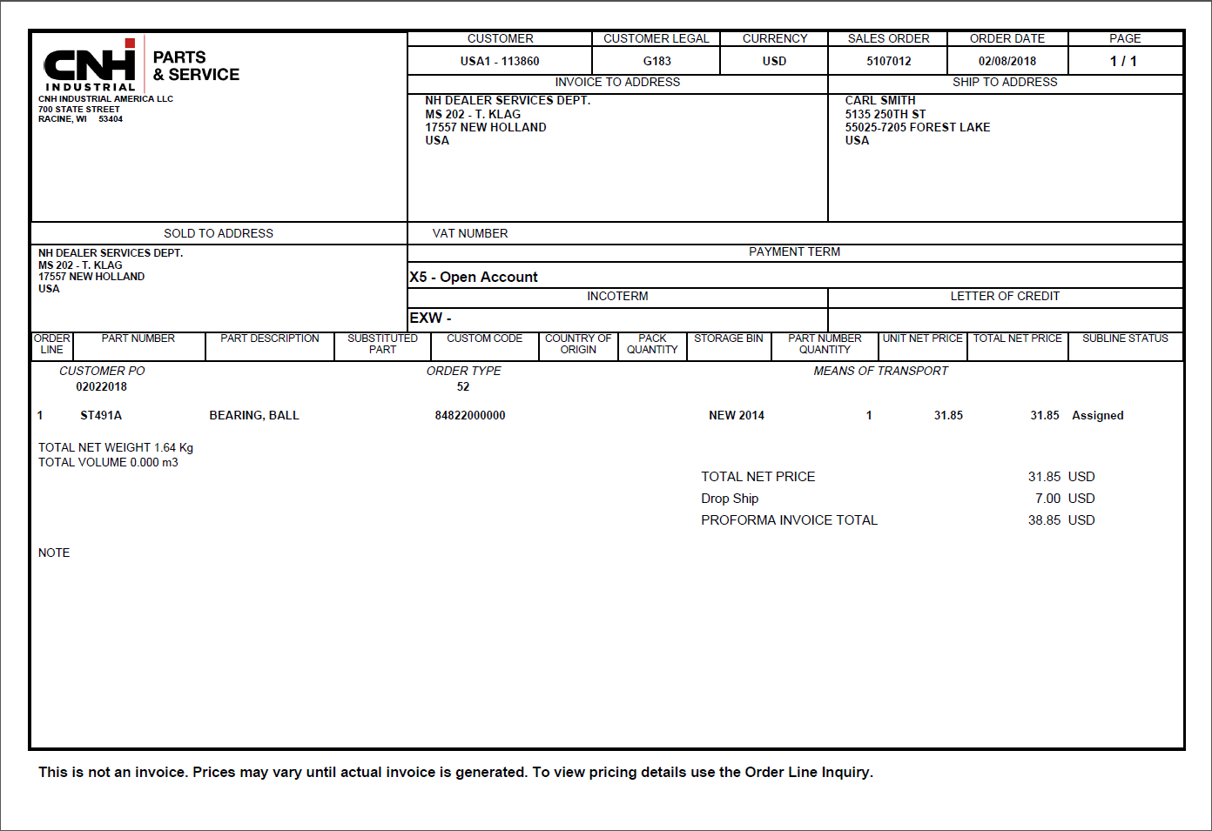

Cancel Order: Click this button to cancel the order’s simulated status. The following window will appear:

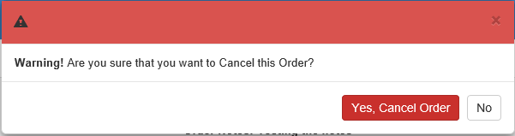

Click Yes, Cancel Order to cancel the simulated order, which will remove it from the CNH Simulated Order list and reset its status to “Open” as though it never got simulated. Click No to keep it.

Close: Click this button to close the window.

